**Assignment**: (Spring Core with Hibernate) - 10_Spring_Assignment1

Develop a menu driven console based java application to facilitate the below operations using Spring Core Dependency Injection

a. Add a Book

b. Delete a Subject

c. Delete a book

d. Search for a book

e. Search for a subject  
f. Sort Book By Title

g. Sort Subject By Subject Title

h. Sort Books by publish Date

i. Exit

**Code**:



**Web Page Screenshots (Angular and Webservice)**:

**Available Options**

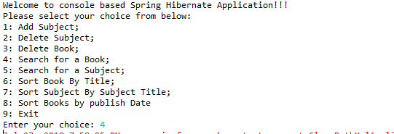



**Sorted Books by Title**

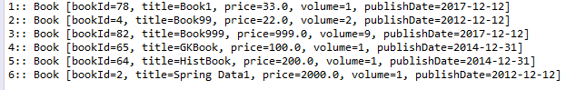

**Sorted Subjects By Subject Title**

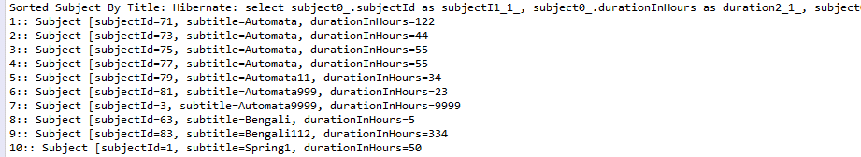

**Sorted Books by Publish Date**

